Project Tycho Data Analysis
A technical reference by Marie Kelly, ©2026
Introduction
Technical Requirements
Summary of Process Steps

Further reference
Microsoft Excel references
Essentials of the Database Environment
Importing the Project Tycho ® Level 1 Data into Microsoft SQL Server

Project Tycho Data Analysis
This is an introductory exercise in data analysis of a simple dataset hosted on healthdata.gov, an official website of the United States Government Department of Health & Human Services:
https://healthdata.gov/dataset/Project-Tycho-Level-1-Data/g89t-x93h/about_data
"The Project Tycho ® Level 1 Data contains US weekly Nationally Notifiable Disease Surveillance Data from 1888 to 2013. These data include tables of disease counts reported by US states and cities to the Federal Health Authorities every week since 1888. These tables have been published in various journals over time and are available in various online repositories but are now also available in digital, computer-readable format."
This exercise uses Microsoft Excel to help answer basic questions about the data:
* What are the most commonly reported disease outbreaks?
* Is there a seasonality to measles outbreaks?
* When have the most widespread outbreaks occurred?
* How often have all states (48-51) reported measles outbreaks in a single week?
* When did the top 10 greatest number of measles cases occur?
* Are there epi_weeks with no recorded measles outbreaks?
* Did reports of measles outbreaks diminish after vaccines were introduced?
Summary of Process Steps
Follow these steps in Excel to process the disease data.
Download guide (graphical steps)
Open the text file, review the data, and save it as an Excel file
Define a table from the data
Create a pivot table for all disease records
Use the pivot table to answer basic questions about the data
Optional:
Using Microsoft SQL Server database to answer disease data questions
Downloading the data: start at healthdata.gov

Click Browse


From View Types, click datasets
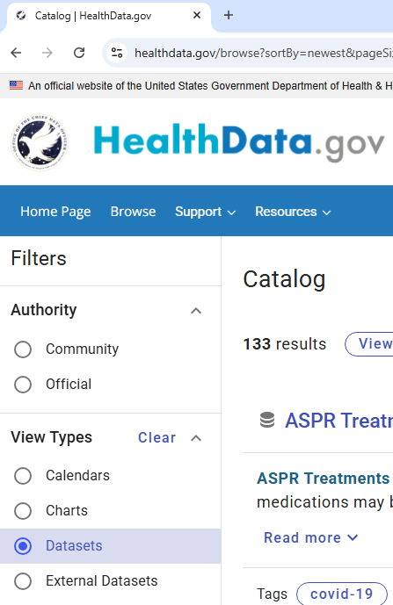
Search for "Project Tycho"
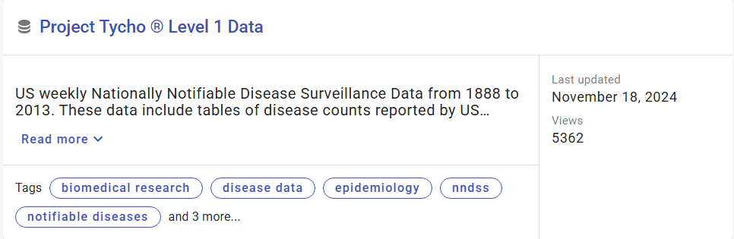

It's possible to query the data directly from this website.
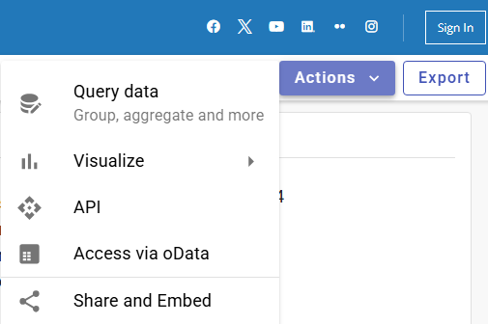

Instead, choose Export (next to Action on the top-level menu) to download the dataset.
Click "Export dataset", then download and save the file to a local folder.
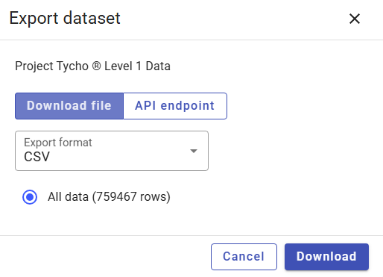


The download site also describes the dataset structure:
https://healthdata.gov/dataset/Project-Tycho-Level-1-Data/g89t-x93h/about_data
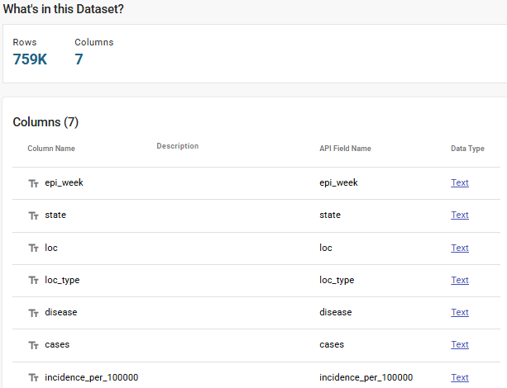

After downloading the dataset, open the file: "g89t-x93h_2021-02-25T15-04-20.csv".
A *.csv file is a text file. "csv" stands for comma separated values, where column values are separated by commas. Instead of commas, some files may contain tabs (an unprintable character) used to separate data between different columns.
Open the csv file with Microsoft Excel and review the data.
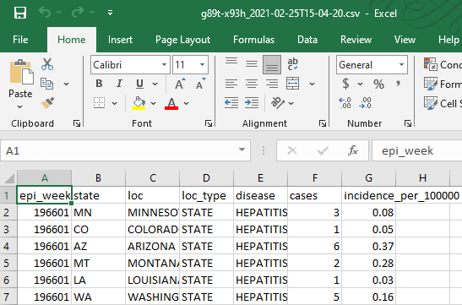
A csv file is a text file with no formatting, which means only letters, numbers and printable symbols, like !@#$%^&*()_+-=, etc. Formatting, including bold, underline, italics, objects like pictures, graphs and maps, hyperlinks or tables … will not be saved in a text file.
Notice the column name epi_weeks in bold below. It won't be possible to save the file as file.csv with any formatting like this. Actually saving the file is allowed, but after it's saved, and re-opened, all that formatting will be gone.
Instead, save the file as an Excel workbook, a file name ending in xlsx.
Go to the File tab (upper left) in Excel, navigate to the "Save As" menu choice below, then select "Save as type: Excel Workbook (.xlsx)" Saving the file as this file type will include formatting, styles, formulas, calculations, graphs, charts and other objects that would be lost if saving only the data in a text file.
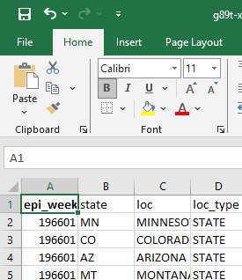
An Excel workbook file (*.xlsx) will enable formatting, data analysis, summarizing and graphing the dataset.
Next, change the data into a table format. A table format will be easier to summarize and graph the data. There are many ways to do this, like CTRL + Shift + End to select the whole data range using the keyboard, or Insert tab on the ribbon, "Insert Table" command.
The "Create Table" dialog box shows the range of the data:

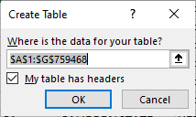
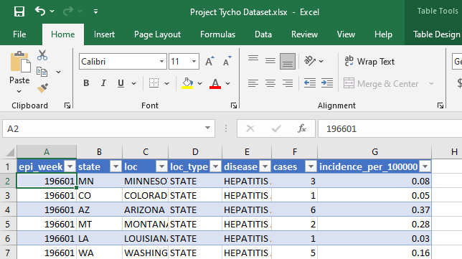
The table design tab enables different formatting options.
Next image: banded rows and filter buttons are removed.
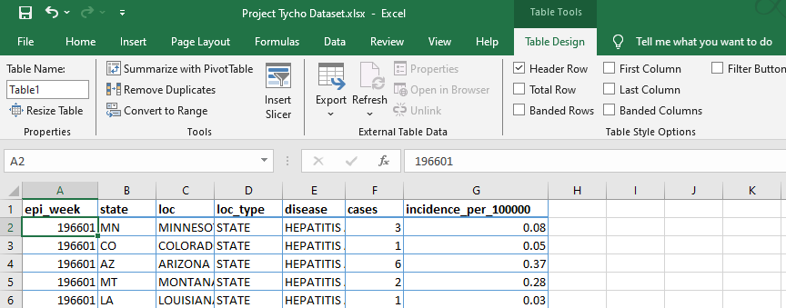

Next, use the new table data to create a pivot table. Go to Insert tab, Pivot Table option.
In order to see the graphic without overlaying the data, choose to option to create the pivot table in a new worksheet.
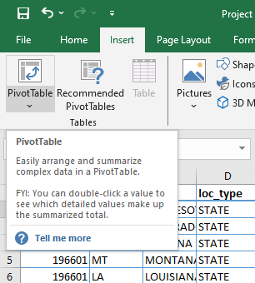
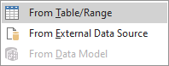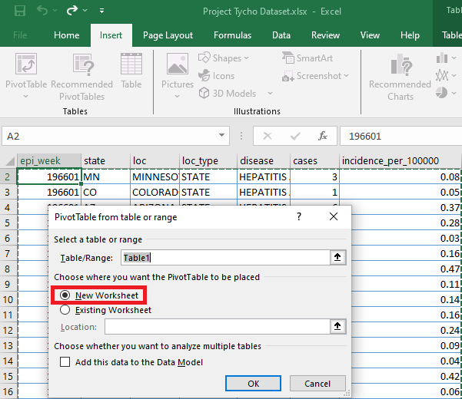
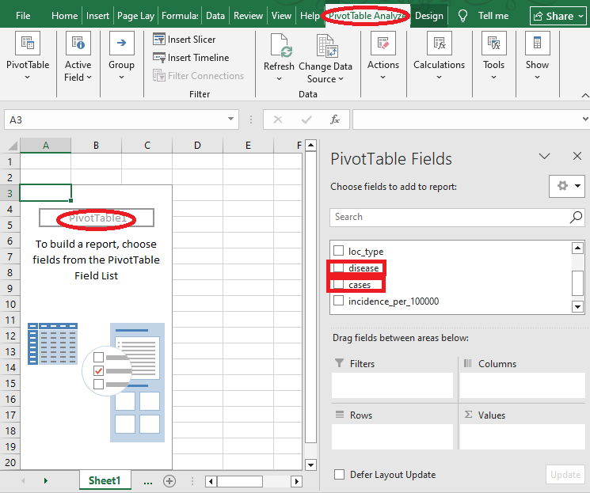
Next, choose the chart rows and values.
Click "disease" to add it to rows. Click "cases", but drag it to values (∑). Initially that will read "Count of cases", but a more accurate statistic would be the "Sum of cases" over time.
Change the "Value Field Settings…" from "Count of cases" to "Sum of cases".
Under "∑ Values" in the lower right, click the drop-down arrow to reveal more choices to group case numbers. Then select sum instead of count.

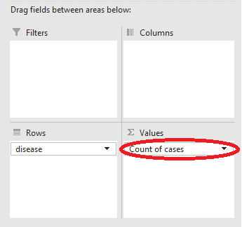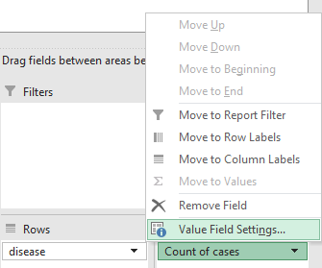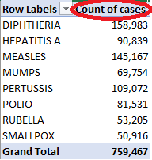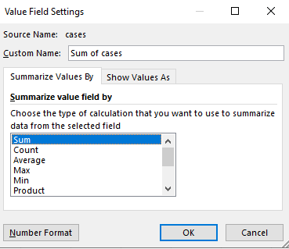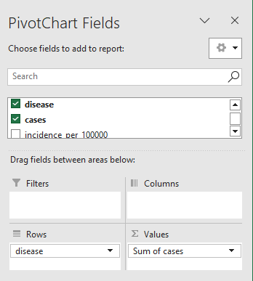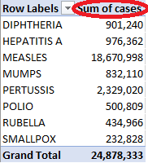

Notice the difference between "count of cases" and "sum of cases". The count of cases is a misrepresentation of total cases. There are 759,467 total records or reports of outbreaks, which is usually multiple cases. The "sum" aggregate statistic adds up the total number of disease cases per report record. That number is over 18 million for measles, and nearly 25 million for all diseases combined in this dataset.
Just one pivot table illustration from Microsoft Excel helps answer this question:
* What are the most commonly reported disease outbreaks?
Diphtheria, pertussis then measles (in that order) appear to have the most reported outbreaks.
But when summing instead of counting the cases, measles has by far the most total cases.
Next question:
* Is there a seasonality to measles outbreaks?
One way to answer this question is to perform a year-over-year comparison, by breaking each epi_week value into year and week. To do this, add a column each for year and week, before the epi_week column in the table. Then populate the new year and week columns.
In the year column, type a function to capture the first four digits of the epi_week value:
=LEFT(C2,4)
In the week column, type a function to capture the last two digits of the epi_week value:
=RIGHT(C2,2)
Then extend the formula down all rows of the data set (cut-and-paste or autofill commands).
After adding values for year and week, extend the table to include the new columns.
Re-size the table from the table design menu: Properties, Resize Table.
Expanding the table will enable year and week values to be used in graphs and charts.

Steps to expand the Excel table

1. Select epi_week column
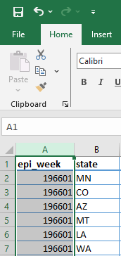
2. Right-click, select Insert

3. New column appears
to the left of epi_week
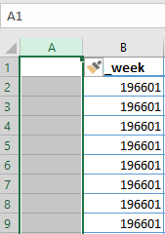
4. Add a second column
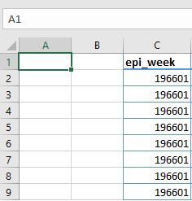
5. Enter year and week
for the new column names
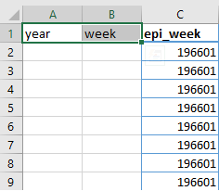

6. Populate year column with
first four numbers in epi_week:
=LEFT(C2,4)
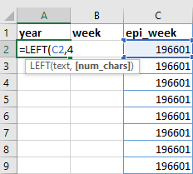
7. Populate week column with
last two numbers in epi_week:
=RIGHT(C2,2)
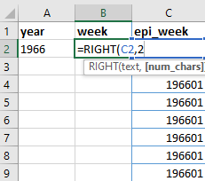

8. Copy and paste or autofill
values in A2 and B2 for all rows.

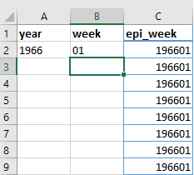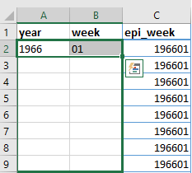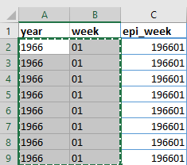

9. Resize table to include the new year and week columns
Re-size the table from the table design menu: Properties, Resize Table.
This command includes the new year and week columns into the Excel table.
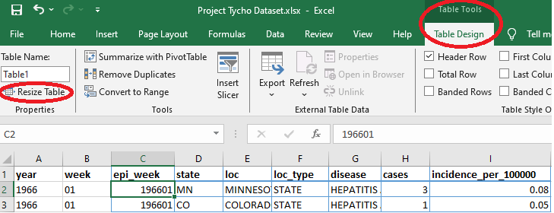
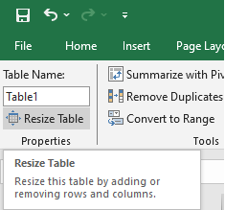
Change $C$1:$I$759468 to $A$1:$I$759468
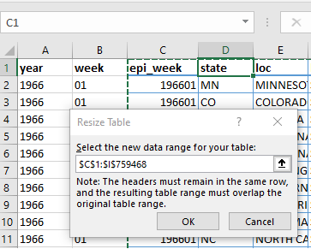
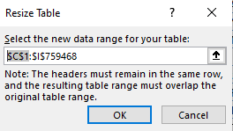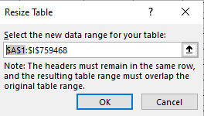

In the Pivot Table tab, use the "Refresh" command to expose the year and week columns added to the table.
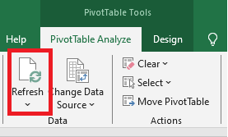
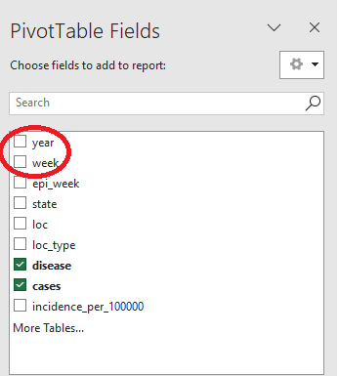

To graph the measles cases by week (year-over-year comparison),
filter the dataset for only measles records.
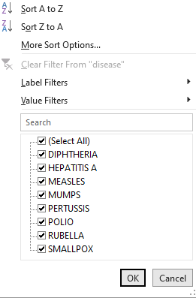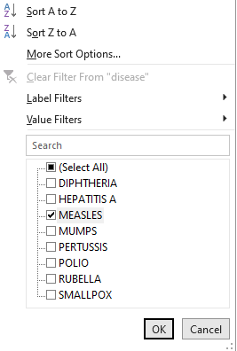

In the Pivot table fields, check week. That will enable comparing measles cases by week (year-over-year comparison). In other words, the horizontal axis will show each week (1-52) and the vertical axis will show the total measles cases for every year with reports for that week.
The Pivot fields should look like this:
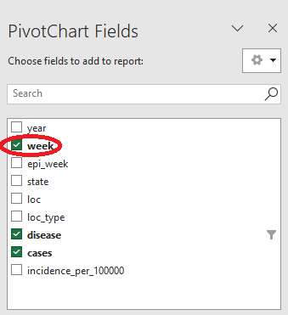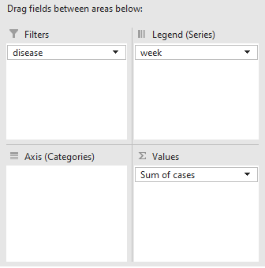
This is a clustered column chart derived from the pivot table in Excel. It's filtered for measles records, and shows a sum of cases for all weeks in the study. The horizontal axis is just a week number, and the vertical axis is the sum of measles cases that week, for 75 years of the study.
This is a very high-level, graphical view, that demonstrates over time, that the late winter through spring weeks of the years 1928-2002 have far more cases than summer or fall seasons for this disease. This graph is a great visualization of measles outbreak seasonality.
* When have the most widespread outbreaks occurred?
A complete answer to this question would address the total number of cases over a time period (probably longer than one week), and include a geography component of how many states reported cases. Start by finding the years with the greatest number of cases reported.
This pivot table in Excel shows total measles cases summarized per year, though it doesn't include any breakdown by states:
To produce this graphic, find the "Pivot Table" command from the Insert menu on the ribbon in Excel. Select "From Table/Range" and choose the dataset with year and month columns added.
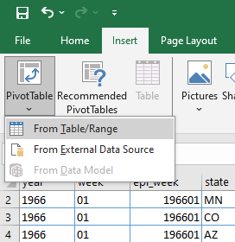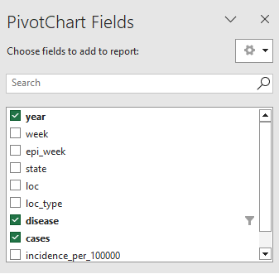

In the PivotChart Fields dialog, select various columns from the dataset by checking the boxes.
When composing this graphic, include "measles" as a disease filter, select "year" to add it to the "Axis", or independent variable of the graphic, and add "cases" to the "Values" category.
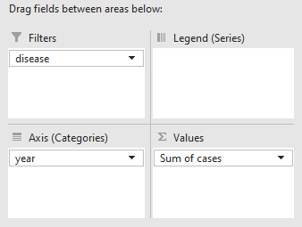
Don't forget to edit the "Value Field Settings…" to change the count of cases to "Sum of cases".
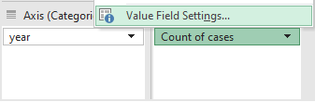
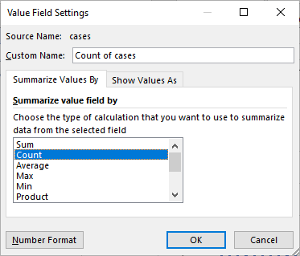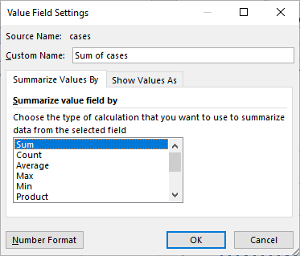
When have the most widespread outbreaks occurred?
The dataset includes records of measles cases for 75 years, from 1928-2002.
Fifteen years have a sum of cases over half a million:
(1934, 1935, 1938, 1941, 1943, 1944, 1946, 1948, 1949, 1951, 1952, 1954, 1955, 1956, 1958)
* How often have all states (48-51) reported measles outbreaks in a single week?

This question can be answered using Excel, but will require a couple extra steps.
First the data needs to be filtered for measles records, and then summed or grouped by epi_week, in order to calculate a count of records for each week.
It's possible to use a pivot table, although it leads only partially to the solution.
If using pivot table, select the table of the disease dataset, go to the Insert tab, select Insert pivot table, and make the following changes. Filter the data for measles records, as described in the previous example, add epi_weeks as a "row" and count of state as a "Values".
First check the column names to add, and then edit the fields further in the PivotTable Fields dialog box. Initially epi_weeks will be added to the values box, because it's recognized as a number in Excel. But the epi_week values aren't included in any calculations, so move the reference from "Values" back to "Rows" under "Drag fields between areas below:" (blue box)
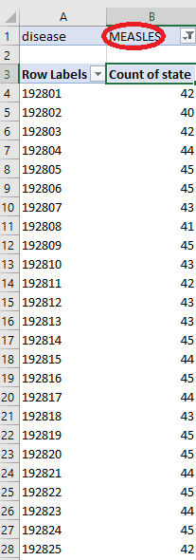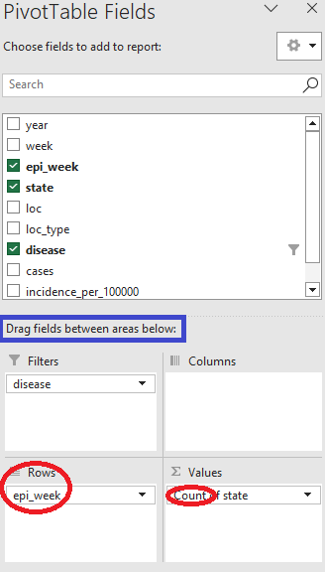

The pivot table comes up with a count of states with records of measles for each epi_week, so what steps are needed to find weeks where almost every state reported cases?
This can be calculated in various ways in Excel, but it will require several steps. The process will include copying the data, then sorting the records by epi_weeks with the most states reporting measles cases, deleting epi-week records with fewer total states reporting, then sorting the remaining records. Finally, a graph is used to illustrate the number of epi_weeks per year in which almost every state reported measles cases.
First, copy values from the pivot table (exclude the grand total record), then paste special (values only) to a separate area of the spreadsheet. (Excel doesn't always allow sorting the pivot table records.) Next sort the pasted values by "Count of state" descending, to produce a list of epi_weeks with the greatest number of states reporting measles cases at the top.

Here is an illustrations of the progression of this data conversion. In columns A and B, the "Row Labels" are all epi_weeks with records of measles cases, while the "Count of state" is the total number of states that reported measles cases that epi_week. Data in these columns came from the pivot table. The remaining columns, "Paste Values" (D and E), "All records sorted by state descending" (G and H), and "48+ states with measles records, sorted by epi_week"
(J and K) contain data derived from the original pivot table. The data in "All records sorted by state descending" contains the "Count of states" reporting measles cases, but in descending order. That list is the same data from "Paste Values", but sorted by the state count.

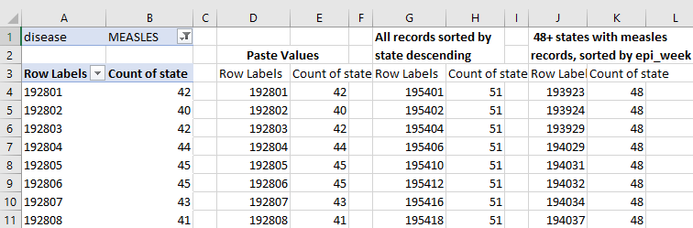

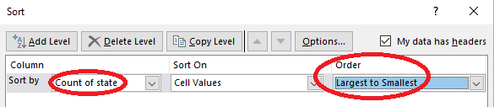
The data in the list "48+ states with measles records, sorted by epi_week" (in columns J and K) has several edits from the previous list. After sorting by "Count of state" in descending order, search for the first occurrence of 47. Then, delete every record with only 47 or fewer states reporting measles cases. That should leave only records with 48, 49 , 50 or 51 states reporting measles cases for those epi_weeks. Finally, return the list to chronological order, by sorting by epi_week (Row Labels) in ascending order.

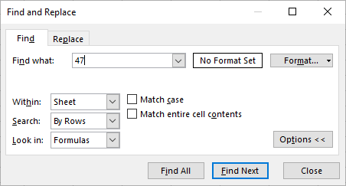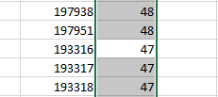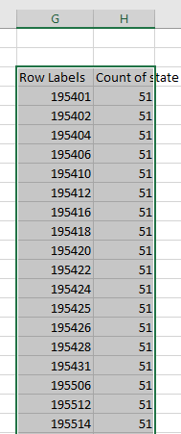

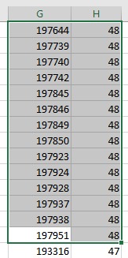

The data in the cells highlighted above include every record with "Count of state" values
of 48, 49, 50 or 51. The reason for this range, is that Alaska became a state January 3, 1959 and
Hawaii became a state August 21, 1959, and didn't report measles cases in this dataset until 1954 (AK) and 1950 (HI). This dataset also includes measles records from District of Columbia, beginning in 1928.

1,144 epi_weeks from 193923 to 197952 reported outbreaks from almost every state.
This occurred an average of 28 weeks per year, over a 40 year period.
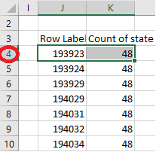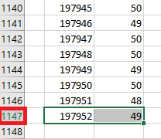

However, an average of this data isn't a meaningful statistic. Some years had more persistent outbreaks of measles compared to other years. Try aggregating the high "Count of state" data by year, and graph that data. Some years (early 1940s, mid 1960s) have nearly every state reporting measles cases almost every week of the year!
This next graphic is confusing: it's the aggregate of an aggregate statistic. There are 1,144 epi_weeks over a 40 year period, in which almost every state reported cases that week. This graphic does not show totals of all cases, nor every week; it shows only totals of those weeks of extreme, widespread outbreaks. At a very high level, it's clearer which years were worse.
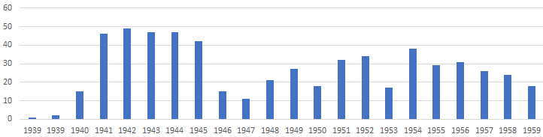
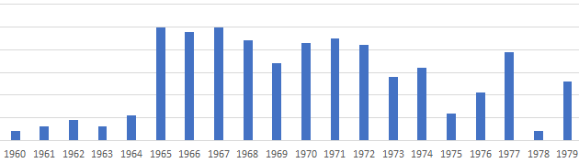

* When did the top 10 greatest number of measles cases occur?
This can be answered in Excel with a few commands.
First, filter the dataset for measles records. Click the drop-down arrow next to "disease" column. A dialog box will appear. Then click the "(Select All)" check box, which will uncheck all options. Finally, select only "Measles" and click ok. The spreadsheet should display only measles records, but don't worry: the other records weren't deleted, they're just hidden.
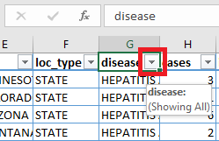
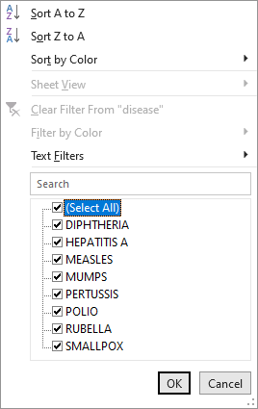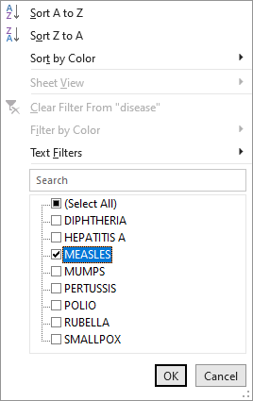

Next, select the "Data" tab on the ribbon:
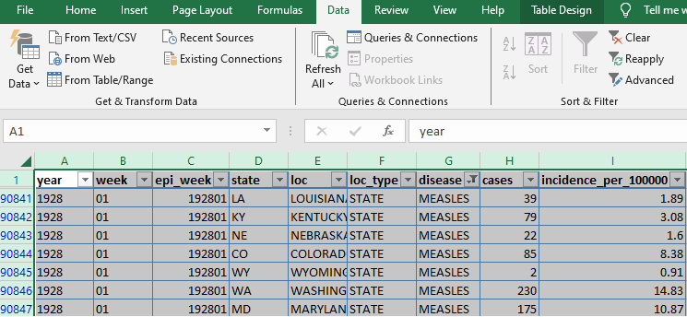
Then click the "Sort" command.
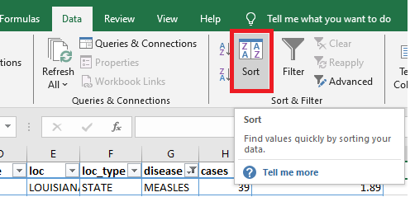
Sort by "cases", ordered "Largest to Smallest"
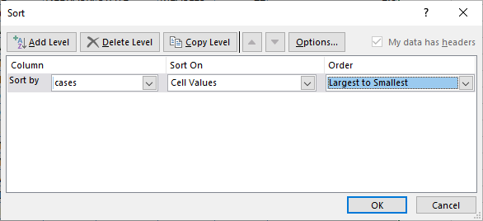

The result shows ten records, of several thousand cases each, for measles in the states: KY, OH, NY and PA. This is just a simple sort command, and doesn't uncover anything beyond a few weeks' data.
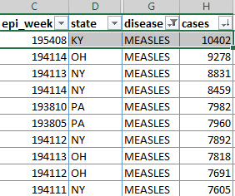

How could the top ten statistic be viewed on a larger scale?
Set up a pivot table in Excel: filter the disease records for "measles", add epi_weeks to "Rows" (move it from "Values", since it isn't being used in a calculation), add cases to "Values", and edit the field settings to calculate a sum instead of count.
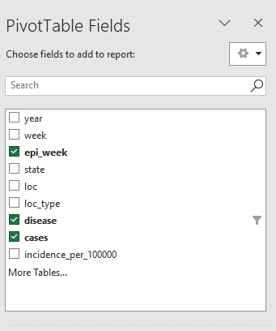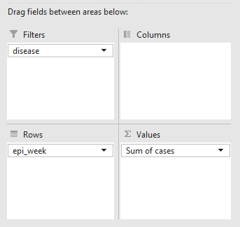

The result (left graphic) from this pivot table shows every epi_week with measles cases reported, and a sum of those cases.
There are 3772 epi_week records in this list, from 192801 – 200252.

Recall in a previous example, the copy-and-paste-special sequence.
Make a copy of the measles epi_week summary data, and sort those records (right graphic)
The top ten epi_week records show cases in the tens of thousands, in late winter and early spring weeks of 1938 and 1941.
Pivot table with measles data

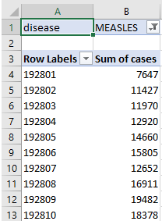
The same data, but a copy of the pivot table, sorted descending by most cases per epi_week
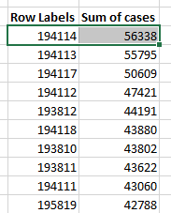

The previous examples highlight the ease and convenience of using pivot tables in Excel.
The next examples will demonstrate how to answer some data questions by running queries in a database environment.

Using Microsoft SQL Server database to answer disease data questions
Some patterns in the data come alive with Excel, by using pivot tables, charts and graphs.
But the database environment can answer more complex data questions, and consider many factors in the same query. Follow the process outlined below, and compare how SQL Server database addresses the same questions as illustrated with Excel in the previous examples.

This example will illustrate how to analyze the Project Tycho dataset, after importing the csv or Excel file, using queries in Microsoft SQL Server. The process to import the dataset is detailed at the end of this document, in the "Further References" section: "Importing the Project Tycho ® Level 1 Data into Microsoft SQL Server".
After importing the data into the tempdb of SQL Server, make a few edits to the data in a query editor, like SQL Server Management Studio. First run this query:
SELECT epi_week, state, loc, loc_type, disease, cases, incidence_per_100000
FROM Tycho_Cases_Temp
Some records don't have a number of cases; set these values to NULL:
UPDATE Tycho_Cases_Temp SET cases = NULL
WHERE cases = '\N'
Then make a new table that includes columns that can be used for numeric operations:
CREATE TABLE Tycho_Cases
(ID int IDENTITY, [Year] smallint, [Week] tinyint, Epi_Week int,
state varchar(2), loc varchar(50), loc_type varchar(10),
disease varchar(50), cases int, incidence_per_100000 numeric(7,2))
Finally, transfer the data from the Tycho_Cases_Temp table to the new table, Tycho_Cases
--(759467 rows affected)
INSERT Tycho_Cases
(Epi_Week, state, loc, loc_type, disease, cases, incidence_per_100000)
SELECT Epi_Week, state, loc, loc_type, disease, cases, incidence_per_100000
FROM Tycho_Cases_Temp
ORDER BY Epi_Week, state
--Update the numeric year and week from epi_week column
UPDATE Tycho_Cases SET
[Year] = LEFT(Epi_Week, 4), [Week] = RIGHT(Epi_Week, 2)
After the task of importing into a database table, the data is now available to run queries similar to the tasks performed with the pivot tables in Excel.

For example, to answer the question,
"What are the most commonly reported disease outbreaks?" try running these queries:
--Total of all cases for each disease in this dataset
SELECT SUM(cases) AS cases, disease
FROM Tycho_Cases
GROUP BY disease
ORDER BY SUM(cases) DESC
--Total of all *** reports of outbreaks ***
SELECT COUNT(cases) AS reports, disease
FROM Tycho_Cases
GROUP BY disease
ORDER BY COUNT(cases) DESC
cases disease
18,670,998 MEASLES
2,329,020 PERTUSSIS
976,362 HEPATITIS A
901,240 DIPHTHERIA
832,110 MUMPS
500,809 POLIO
434,966 RUBELLA
232,828 SMALLPOX
reports disease
158,983 DIPHTHERIA
145,167 MEASLES
109,072 PERTUSSIS
90,839 HEPATITIS A
81,484 POLIO
69,754 MUMPS
53,205 RUBELLA
50,916 SMALLPOX
Recall how it took several steps to answer this question with Excel:
When did the top 10 greatest number of measles cases occur?
Try running this query against the database:
--When did the top 10 greatest number of measles cases occur?
SELECT epi_week, COUNT(DISTINCT state) AS d_states, SUM(cases) AS cases
FROM Tycho_Cases
WHERE disease = 'MEASLES'
GROUP BY epi_week
ORDER BY SUM(cases) DESC

With one short query, the database answers these questions even faster than Excel.
epi_week d_states cases
194114 48 56,338
194113 48 55,795
194117 48 50,609
194112 48 47,421
193812 46 44,191
194118 48 43,880
193810 46 43,802
193811 46 43,622
194111 48 43,060
195819 50 42,788
One more query that demonstrates the time period that these diseases were reported.
--Date range of records for each disease
SELECT disease,
MIN([Year]) AS MIN_Y, MAX([Year]) AS MAX_Y,
MIN(epi_week) AS MIN_ew, MAX(epi_week) AS MAX_ew,
COUNT(ID) AS reports, SUM(cases) AS cases
FROM Tycho_Cases
GROUP BY disease
ORDER BY disease
disease MIN / MAX_Y MIN_ew MAX_ew Total Total
Reports Cases
DIPHTHERIA 1916 1947 191601 194752 158,983 901,240
HEPATITIS A 1966 2011 196601 201152 90,839 976,362
MEASLES 1928 2002 192801 200252 145,167 18,670,998
MUMPS 1968 2002 196801 200252 69,754 832,110
PERTUSSIS 1938 2011 193801 201152 109,072 2,329,020
POLIO 1928 1968 192801 196852 81,531 500,809
RUBELLA 1966 2002 196601 200252 53,205 434,966
SMALLPOX 1928 1952 192801 195250 50,916 232,828
* Are there epi_weeks with no recorded measles outbreaks?
This is difficult at best to answer in Excel, because the question asks about missing data.
Running specific queries against a database can quickly uncover trends and patterns, calculate totals, sort data and even identify missing data.

First, find all weeks in the dataset.
SELECT MIN([Year]) AS MIN_Y, MAX([Year]) AS MAX_Y,
MIN(epi_week) AS MIN_ew, MAX(epi_week) AS MAX_ew
FROM Tycho_Cases
MIN_Y MAX_Y MIN_ew MAX_ew
1916 2011 191601 201152

Then create a table and insert every consecutive year and week over the study time frame.
CREATE TABLE Epi_Weeks
([Year] smallint, [Week] tinyint, Epi_Week int)
Take a deep breath before moving to the next page.
Warning: outrageous query ahead…
--Get epi_weeks from 1916 to 2011: 96 years X 52 weeks = 4992 Epi_Weeks
--(4992 rows affected)
INSERT Epi_Weeks ([Year], [Week])
SELECT sq1.[Year], sq2.[Week]
FROM
(SELECT 1916 AS [Year] UNION SELECT 1917 UNION SELECT 1918 UNION SELECT 1919 UNION
SELECT 1920 UNION SELECT 1921 UNION SELECT 1922 UNION SELECT 1923 UNION SELECT 1924 UNION
SELECT 1925 UNION SELECT 1926 UNION SELECT 1927 UNION SELECT 1928 UNION SELECT 1929 UNION
SELECT 1930 UNION SELECT 1931 UNION SELECT 1932 UNION SELECT 1933 UNION SELECT 1934 UNION
SELECT 1935 UNION SELECT 1936 UNION SELECT 1937 UNION SELECT 1938 UNION SELECT 1939 UNION
SELECT 1940 UNION SELECT 1941 UNION SELECT 1942 UNION SELECT 1943 UNION SELECT 1944 UNION
SELECT 1945 UNION SELECT 1946 UNION SELECT 1947 UNION SELECT 1948 UNION SELECT 1949 UNION
SELECT 1950 UNION SELECT 1951 UNION SELECT 1952 UNION SELECT 1953 UNION SELECT 1954 UNION
SELECT 1955 UNION SELECT 1956 UNION SELECT 1957 UNION SELECT 1958 UNION SELECT 1959 UNION
SELECT 1960 UNION SELECT 1961 UNION SELECT 1962 UNION SELECT 1963 UNION SELECT 1964 UNION
SELECT 1965 UNION SELECT 1966 UNION SELECT 1967 UNION SELECT 1968 UNION SELECT 1969 UNION
SELECT 1970 UNION SELECT 1971 UNION SELECT 1972 UNION SELECT 1973 UNION SELECT 1974 UNION
SELECT 1975 UNION SELECT 1976 UNION SELECT 1977 UNION SELECT 1978 UNION SELECT 1979 UNION
SELECT 1980 UNION SELECT 1981 UNION SELECT 1982 UNION SELECT 1983 UNION SELECT 1984 UNION
SELECT 1985 UNION SELECT 1986 UNION SELECT 1987 UNION SELECT 1988 UNION SELECT 1989 UNION
SELECT 1990 UNION SELECT 1991 UNION SELECT 1992 UNION SELECT 1993 UNION SELECT 1994 UNION
SELECT 1995 UNION SELECT 1996 UNION SELECT 1997 UNION SELECT 1998 UNION SELECT 1999 UNION
SELECT 2000 UNION SELECT 2001 UNION SELECT 2002 UNION SELECT 2003 UNION SELECT 2004 UNION
SELECT 2005 UNION SELECT 2006 UNION SELECT 2007 UNION SELECT 2008 UNION SELECT 2009 UNION
SELECT 2010 UNION SELECT 2011) sq1
CROSS JOIN
(SELECT 1 AS [Week] UNION SELECT 2 UNION SELECT 3 UNION SELECT 4 UNION SELECT 5 UNION
SELECT 6 UNION SELECT 7 UNION SELECT 8 UNION SELECT 9 UNION SELECT 10 UNION
SELECT 11 UNION SELECT 12 UNION SELECT 13 UNION SELECT 14 UNION SELECT 15 UNION
SELECT 16 UNION SELECT 17 UNION SELECT 18 UNION SELECT 19 UNION SELECT 20 UNION
SELECT 21 UNION SELECT 22 UNION SELECT 23 UNION SELECT 24 UNION SELECT 25 UNION
SELECT 26 UNION SELECT 27 UNION SELECT 28 UNION SELECT 29 UNION SELECT 30 UNION
SELECT 31 UNION SELECT 32 UNION SELECT 33 UNION SELECT 34 UNION SELECT 35 UNION
SELECT 36 UNION SELECT 37 UNION SELECT 38 UNION SELECT 39 UNION SELECT 40 UNION
SELECT 41 UNION SELECT 42 UNION SELECT 43 UNION SELECT 44 UNION SELECT 45 UNION
SELECT 46 UNION SELECT 47 UNION SELECT 48 UNION SELECT 49 UNION SELECT 50 UNION
SELECT 51 UNION SELECT 52) sq2
ORDER BY sq1.[Year], sq2.[Week]
--UPDATE Epi_Week column to its value based on Year and Week
UPDATE Epi_Weeks SET Epi_Week = RTRIM(CAST([Year] AS char)) + CASE
WHEN [Week] BETWEEN 1 AND 9 THEN '0' + RTRIM(CAST([Week] AS char))
ELSE RTRIM(CAST([Week] AS char)) END
--4992 total epi_weeks in the entire study period
SELECT [Year], [Week], Epi_Week
FROM Epi_Weeks
ORDER BY Epi_Week

Year Week Epi_Week
1916 1 191601
1916 2 191602
1916 3 191603
1916 4 191604
1916 5 191605
1916 6 191606
…
…
Year Week Epi_Week
2011 47 201147
2011 48 201148
2011 49 201149
2011 50 201150
2011 51 201151
2011 52 201152

Combine the measles data and series of all epi_weeks, to determine if there are epi_weeks with no recorded measles outbreaks.
--Find epi_week of first and last 'MEASLES' record
SELECT MIN(epi_week) AS min_w, MAX(epi_week) AS max_w,
COUNT(DISTINCT epi_week) AS ews
FROM Tycho_Cases
WHERE disease = 'MEASLES'
min_w max_w ews
192801 200252 3,772 --Distinct weeks of measles records
Then find every epi_week in that time interval
--(3900 row(s) affected)
--In other words, 3,900 total epi_weeks in those 75 years.
--Use year values in the previous query from the Tycho_Cases table
SELECT [Year], [Week], Epi_Week
FROM Epi_Weeks
WHERE [Year] BETWEEN 1928 AND 2002
ORDER BY Epi_Week
--The database can combine data from epi_weeks table with Tycho_Cases
--Find epi_weeks in the interval of all measles records (1928-2002),
--that didn't have a record for measles
SELECT [Year], [Week], Epi_Week
FROM Epi_Weeks
WHERE [Year] BETWEEN 1928 AND 2002
AND Epi_Week NOT IN
(SELECT epi_week FROM Tycho_Cases WHERE disease = 'MEASLES')
ORDER BY Epi_Week
Only 128 epi_weeks didn't have a record for measles, over a time period of 75 years in the study data. (3,900 total weeks – 128 weeks = 3,772 weeks with measles records)
Year Week Epi_Week
1936 51 193651
1936 52 193652
1939 41 193941
1940 18 194018
1940 38 194038
1940 51 194051
…
…
Year Week Epi_Week
2002 7 200207
2002 8 200208
2002 9 200209
2002 10 200210
2002 49 200249
2002 50 200250

* Did reports of measles outbreaks diminish after vaccines were introduced?

First consider the timeline of vaccine development. The first measles vaccines were available in 1963 and were replaced with a more effective vaccine in 1968. The combination measles vaccines in use today first became available in 1971 (MMR) and 2005 (MMRV).

World Health Organization, History of the Measles Vaccine
https://www.who.int/news-room/spotlight/history-of-vaccination/history-of-measles-vaccination

History of measles: Outbreaks and vaccine timeline
https://www.mayoclinic.org/diseases-conditions/history-disease-outbreaks-vaccine-timeline/measles

NIH, National Library of Medicine:
Measles Vaccination Before the Measles-Mumps-Rubella Vaccine
https://pmc.ncbi.nlm.nih.gov/articles/PMC4007870/
In the case of measles, the Tycho dataset illustrates a dramatic decrease in measles cases once the vaccine was introduced. Recall the example earlier in this document, using a pivot table in Excel, plotting the year against the sum of cases over the time interval with measles records, 1928 – 2002. The graphic illustrates this decline in total cases in the 1960's. There have been outbreaks even after the introduction of vaccines, but case totals are much smaller.

In SQL Server, run this query against the Tycho_Cases table:
--Total of all cases for 'MEASLES' in this dataset
SELECT SUM(cases) AS Cases, Year
FROM Tycho_Cases
WHERE disease = 'MEASLES'
GROUP BY Year
ORDER BY Year
Notice a dramatic decline in total cases reported after the introduction of the measles vaccine.
Cases Year
502,859 1951
588,052 1952
433,993 1953
686,492 1954
529,705 1955
616,050 1956
460,821 1957
707,368 1958
374,503 1959
432,221 1960
402,551 1961
476,141 1962
332,057 1963
431,259 1964
264,303 1965
201,064 1966
59,258 1967
22,879 1968
24,190 1969
45,697 1970
71,878 1971
30,121 1972
25,657 1973
21,072 1974
23,845 1975
39,001 1976
49,654 1977
26,884 1978
12,781 1979
13,047 1980

Technical Requirements
This exercise includes downloading a large disease dataset and analysis
with Microsoft Excel (a spreadsheet program) and SQL Server (a database software).
The user will need to use a computer with Microsoft Excel installed and an internet connection to download a file from a public website. The database exercise uses Microsoft SQL Server to compare the same processes from Excel, and highlights the data analysis steps that might be more practical using database queries instead of a spreadsheet.
Optional Exercise
In order to run the database queries, the user will need to install Microsoft SQL Server, create some tables and import the data file. A Windows-based machine is required to run SQL Server.
A database server and client are required. A database server is needed to import the disease dataset (file name, "g89t-x93h_2024-11-18T13-13-42.csv") from the healthdata.gov site, and a database client is required to run queries against the imported file.
This document demonstrates the process using Microsoft SQL Server database software.
The Microsoft SQL Server database server includes tools to import data, like text files.
SQL Server Management Studio is a database client tool that can query the database server.

*****************************************************************************Microsoft Excel references
Microsoft Excel is a spreadsheet program developed by Microsoft, initially released in 1985. It runs on Microsoft, Apple and Android operating systems. It can be installed locally on a desktop computer, or run from a cloud-based system:
Excel for free on the web
https://excel.cloud.microsoft/en-us/
Microsoft Excel 365
https://www.microsoft.com/en-us/microsoft-365/excel
Microsoft Excel 365 is similar to a spreadsheet installed on a desktop computer, except that the cost is figured in a subscription price, and the content is upgraded continuously. The benefit is that the user doesn't worry as much as version of the spreadsheet, and the online software always has the latest features in production.
Alternately, standalone installations of Microsoft Excel are available.
Microsoft Excel is the spreadsheet program that is part of a complete series of computer software known as Microsoft Office, or Office. Standalone versions of Office are available in these versions: 2024, 2021, 2019 and 2016. Earlier versions of Office are now unsupported:
https://endoflife.date/office
Recommended References: Sometimes a book can highlight the most commonly used features in software better than the native help files. For example, Microsoft Excel has over 450 built-in functions, but it may be easy for the beginner to get acquainted with the most commonly used functions and get more specific from there. Books are a great at introducing the most important functions the software performs. Of course, there are also great references online including website help sites and instructional videos.
Lisa A. Bucki, Excel Portable Genius, Wiley, 2020
ISBN: 978-1-119-76361-1

Mike McGrath and Michael Price, Microsoft Excel in Easy Steps, Illustrated using Excel in Microsoft 365, In Easy Steps Limited, 2023, ineasysteps.com
ISBN: 978-1-84078-996-6
*****************************************************************************

*****************************************************************************
Essentials of the Database Environment

Client and server terminology
A database server is needed to import data from other sources, like flat files or spreadsheets.
A "server" is required to receive database commands from a client.
A "client" is required to send database commands like "SELECT" queries to a database server.

Downloading and installing a database client will enable connecting to a database server:
SQL Server Management Studio
https://learn.microsoft.com/en-us/ssms/download-sql-server-management-studio-ssms

Downloading and installing a database server:
Microsoft SQL Server is available as a free download (certain editions):
https://www.microsoft.com/en-us/sql-server/sql-server-downloads

Download a free specialized edition:
Developer
SQL Server 2022 Developer is a full-featured free edition, licensed for use as a development and test database in a non-production environment.
Express
SQL Server 2022 Express is a free edition of SQL Server, ideal for development and production for desktop, web, and small server applications.

Microsoft SQL Server is also available for download from third parties, which might offer earlier versions with fewer installation requirements. Using Microsoft SQL Server in a production setting for commercial purposes requires purchase and is subject to licensing terms.

Using the import file feature of Microsoft SQL Server:
https://learn.microsoft.com/en-us/sql/relational-databases/import-export/import-flat-file-wizard?view=sql-server-ver16

What is the most recent version of Microsoft SQL Server?
https://sqlserverbuilds.blogspot.com/
SQL Server 2025 (SQL Server version 17) was announced on November 19, 2024.
SQL Server 2022 (SQL Server version 16) was released to manufacturing (RTM)
on November 16, 2022.
Its most current version number is: 16.0.1000.6, with CU19 (16.0.4195.2, May 2025)
*****************************************************************************
Importing the Project Tycho ® Level 1 Data into Microsoft SQL Server
Import the text file into a table in the database server

There are several ways to perform the same task, even in Microsoft SQL Server. The process outlined here is the simplest method to import a text file to a database table, changing the fewest default options as possible. The user needs permissions to create a table and import data into the tempdb database in SQL Server.
The screenshot below shows the SQL Server Management Studio, Databases folder. Select the tempdb database.
Tasks, "Import Data"
Right-click on the tempdb database to view the "Import Data" option.
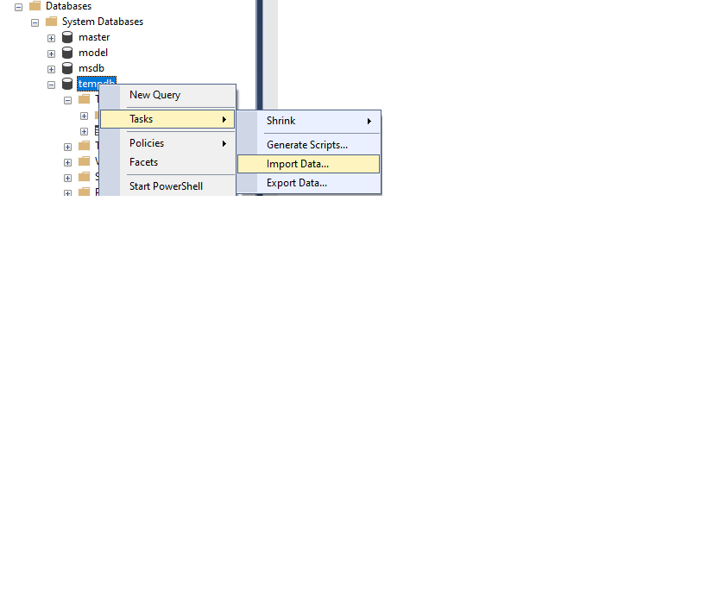

Import and Export Wizard
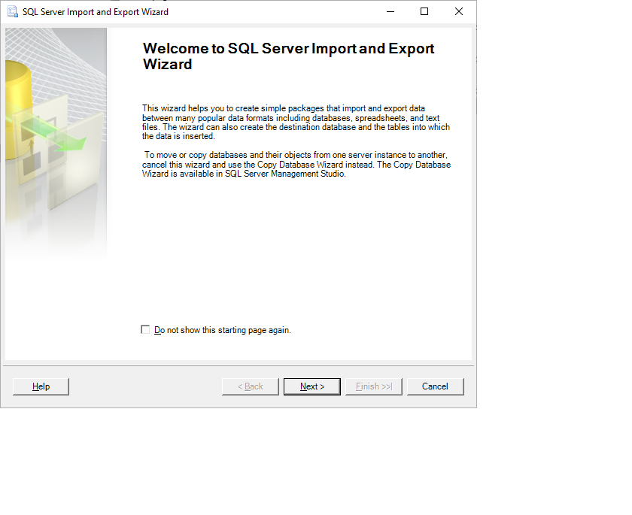


Choose a Data Source
In the "Choose a Data Source" dialog, first, change the "Data source" from ".Net Framework Data Provider for Odbc" to "Flat File Source".
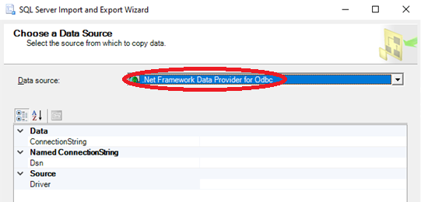
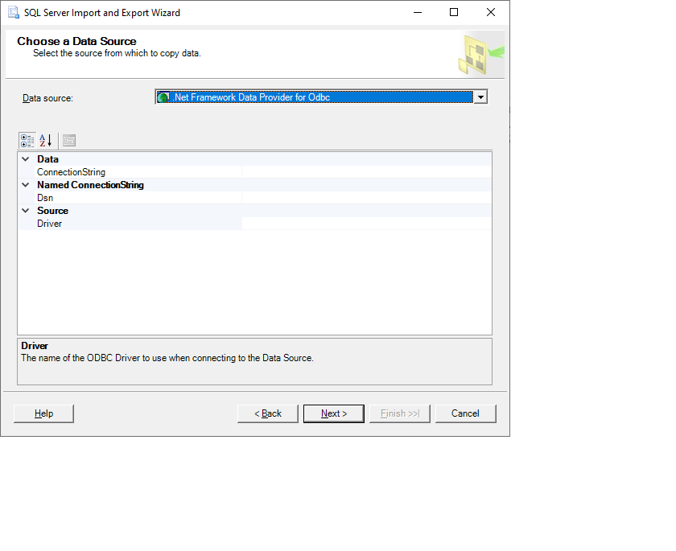

Change Data Source: click the drop-down arrow on the far right to view more data sources.
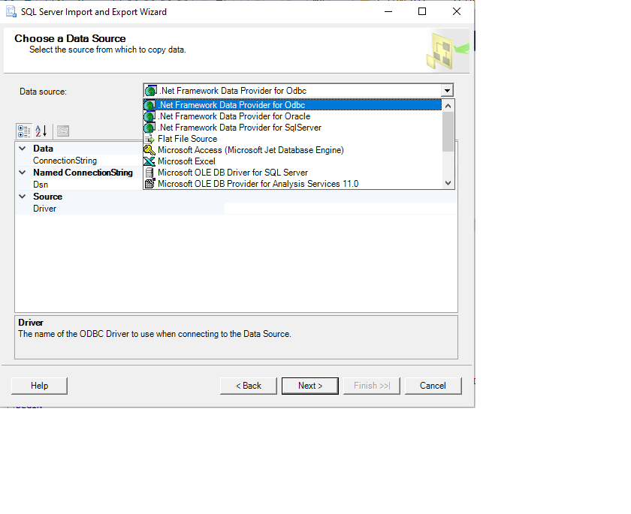
Select Flat File Source
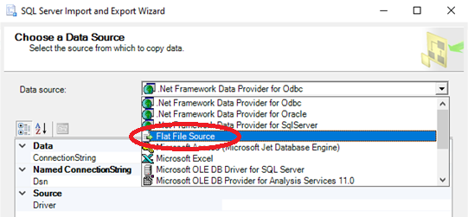
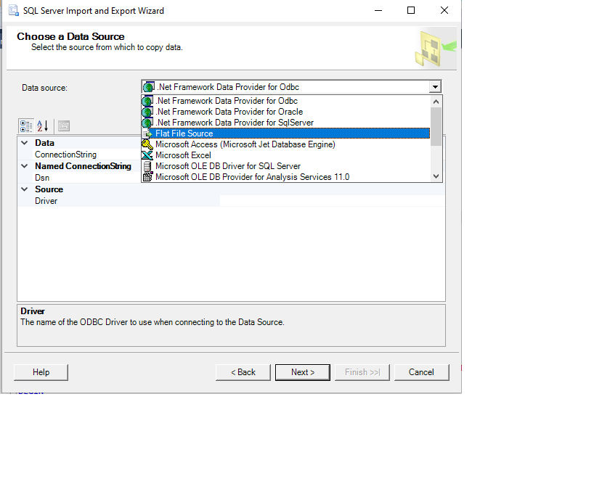
Note: several steps are performed in "Choose a Data Source"
to select options in the flat file source format before moving onto the next screen.
Data source (provide the file location and name),
"General", "Columns" and "Advanced" tabs (at left) all require special edits.
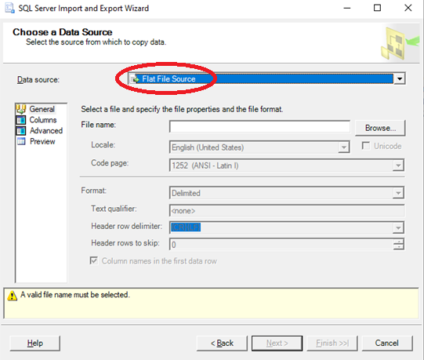


Flat File Source Options: click "Browse…" to find the file to import into SQL Server.
"C:\Downloads\g89t-x93h_2021-02-25T15-04-20.csv"
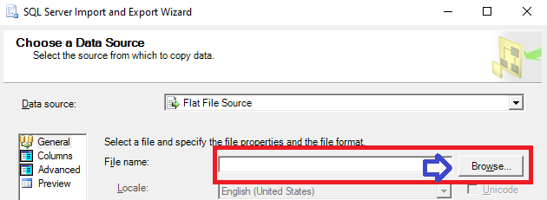
If the file doesn't appear in the "Open" file dialog box,
check the file type in the lower right.
Change the file type from "Text files" to "CSV files" and check again for the file name.

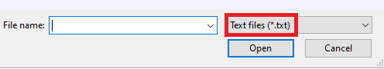




The file, "g89t-x93h_2021-02-25T15-04-20.csv" was downloaded from healthdata.gov:
https://healthdata.gov/dataset/Project-Tycho-Level-1-Data/g89t-x93h/about_data

Choose a Data Source, "Flat File Source",
"Select a file and specify file properties and the file format."

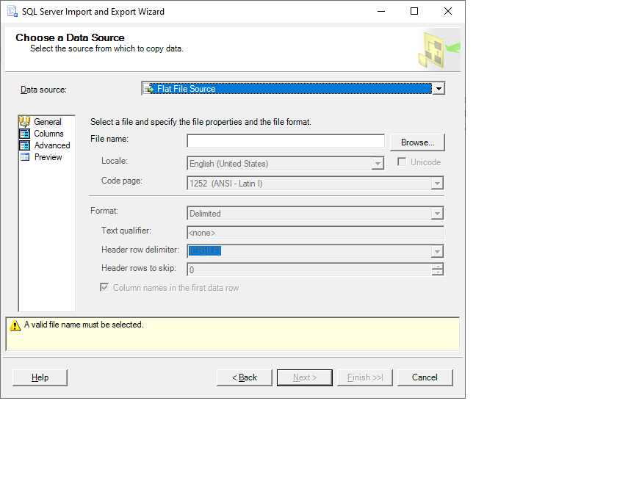

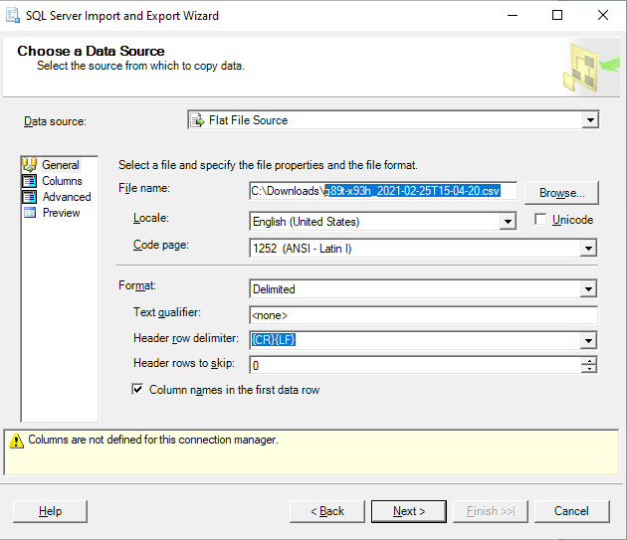

Flat File Source Options, "General":
This file is organized into columns, so the "Format" options should include "Delimited", Text qualifier "<none>", Header row delimiter: "{CR}{LF}" and Header rows to skip: "0".
Be sure to check "Column names in the first data row".
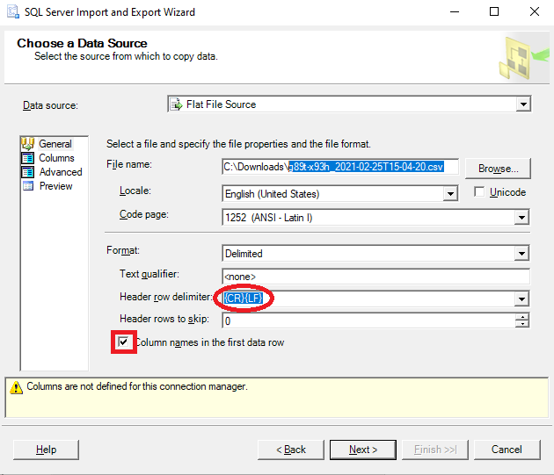

Flat File Source Column Options; click the "Columns" tab on the left
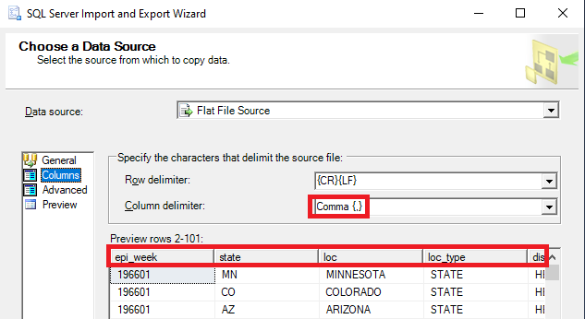
… Scroll to the right to see the rest of the columns in the file:
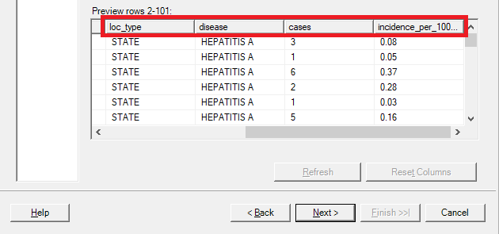

Each line in the file is a row, or unique record imported into the database.
The delimiter for each row is a carriage return / line feed, or {CR}{LF}
The column delimiter is a comma.
If in doubt about the column delimiter in a flat file, just open with a text editor to confirm:
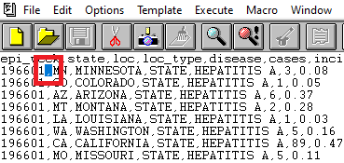
The column headers for this file are:
"epi_week, state, loc, loc_type, disease, cases, incidence_per_100000"
The download site also describes the dataset structure:
https://healthdata.gov/dataset/Project-Tycho-Level-1-Data/g89t-x93h/about_data



Flat File Source Advanced Options: click "Advanced" tab in the left…

Each column has a column delimiter (but they are all commas in this file),
a column data type, and a column width.
Those properties can be modified for each column in the source file.
Note the graphic below: it shows column properties just for epi_week;
click on other column names to change those properties.
It's possible to change these to a different type (like numeric) or a different width,
but initially just try this process with these defaults, and see if it works without errors.

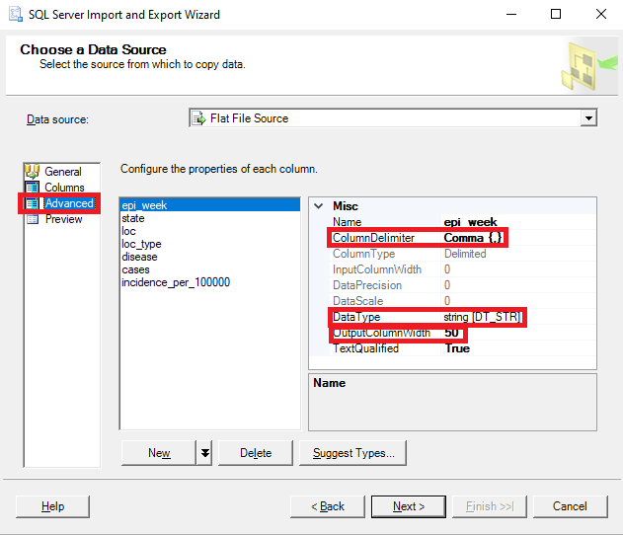

Flat File Source Preview: click "Preview" tab on the left…
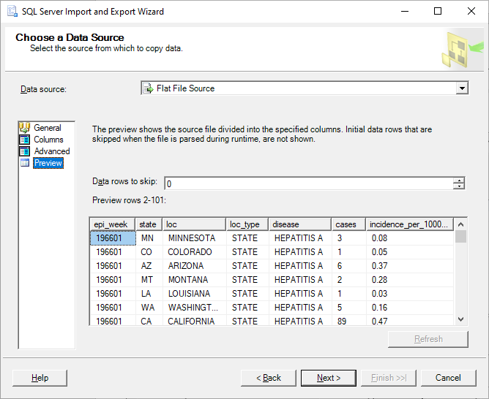
Click "Next" to "Choose a Destination, Specify where to copy data to."
Choose "Microsoft OLE DB Driver for SQL Server".
".Net Framework Data Provider for SQL Server" also works
but may take longer to import a large file.
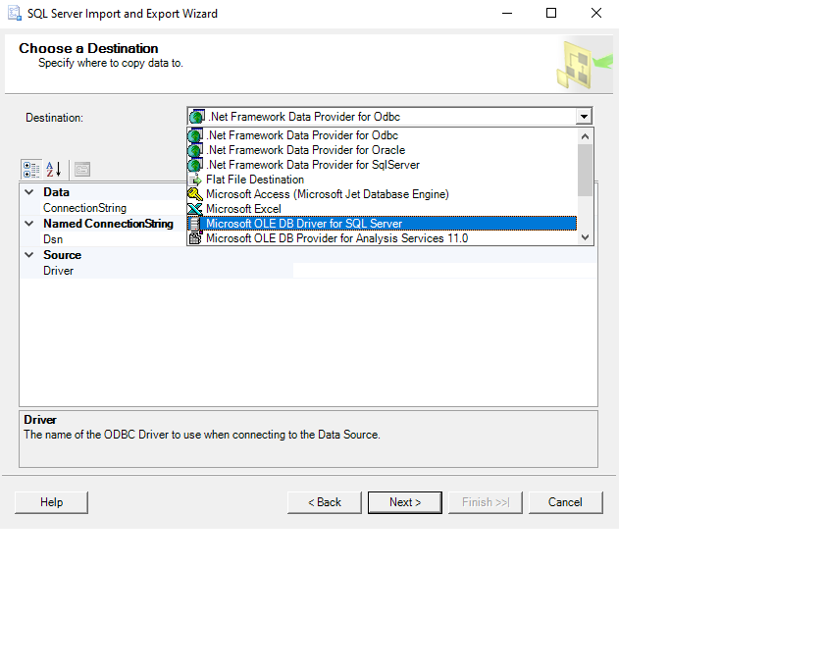

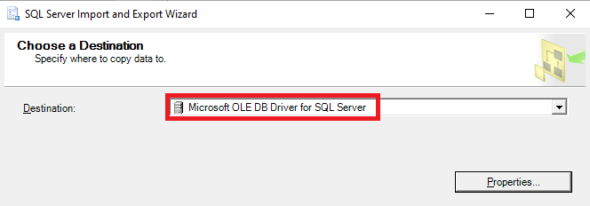
"Choose a Destination", Click "Properties…" to view database security options.
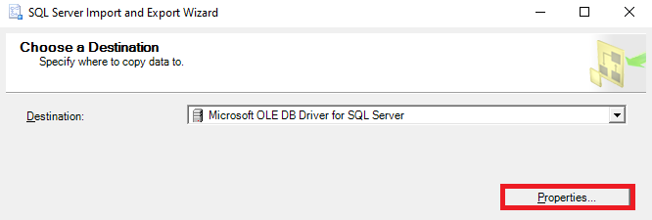
Enter these fields carefully to avoid timeout errors on connections.
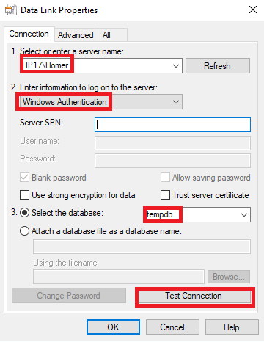
Test Connection Succeeded
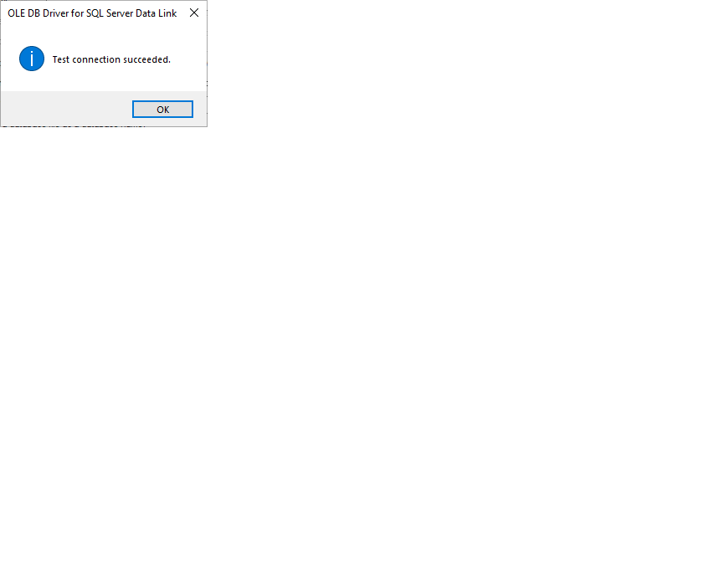
Data Link Properties:
Connect to a SQL Server
Enter the server name if it doesn't automatically populate. It should be formatted like "Hostname\InstanceName"
"Enter information to log on to the server:"
will accept a user name and password,
or use Windows Authentication.
Select the database to import the file into.
This example uses the tempdb database.
Click "Test Connection" button in the lower right.
If successful, click "Next >"

Click "Next' to
"Select Source Tables and Views, Specify where to copy data to."
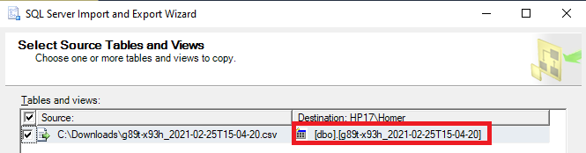
Consider changing the destination table name… For example, Tycho_Cases_Temp
The new name will be the name of the table in the database.
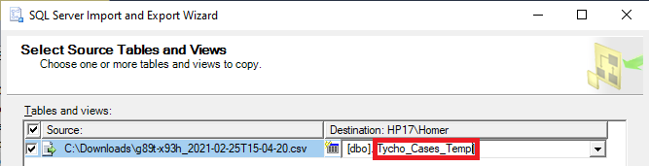
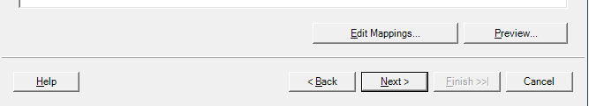

Click "Edit Mappings…" to view the data types of the columns in the source file.
The import process interprets each column type as text, allows blank values (Nullable), and accepts each column value of 50 characters or less without throwing an error.
It's possible to change these before the import process, but it's easier to stay with these defaults and change the column definitions after the table is created in the database,
or even move the raw data into a different table later in SQL Server.
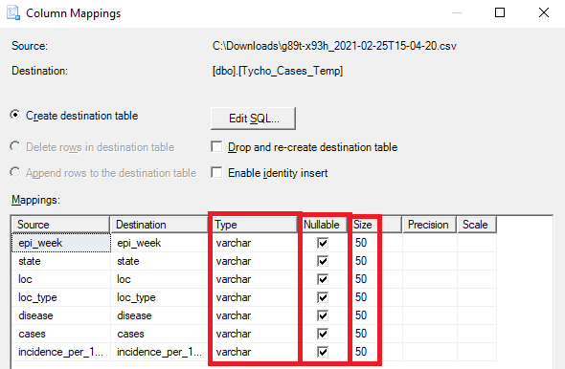
Optionally edit the table definition with the "Edit SQL…" option
in the Create destination table step.
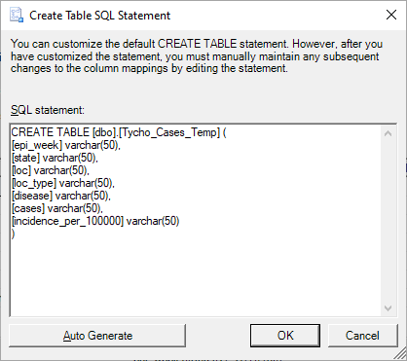
Data View: from " Select Source Tables and Views: Preview…", in the lower right.
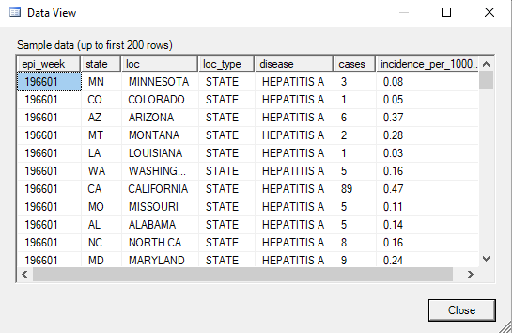
Save and Run Package
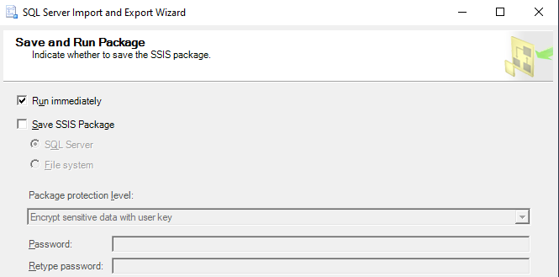

Click "Finish" to perform the following actions
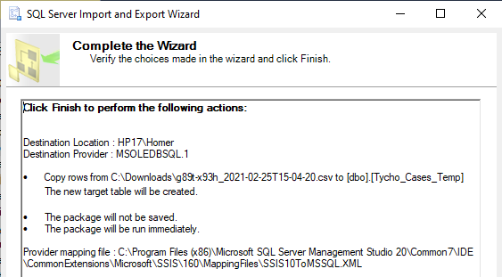

The execution was successful: check the rows transferred near the end of the output:
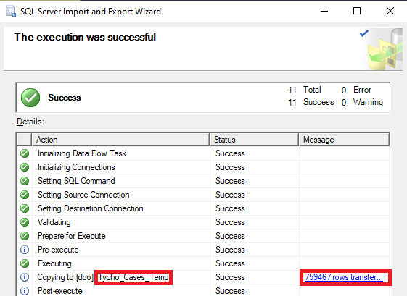
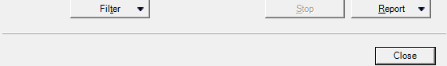
… compare this to the line numbers (plus header row) in the file, as viewed in a text editor:
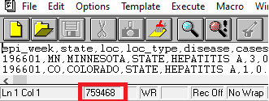
Check the tempdb database to view the new table, "Tycho_Cases_Temp"
